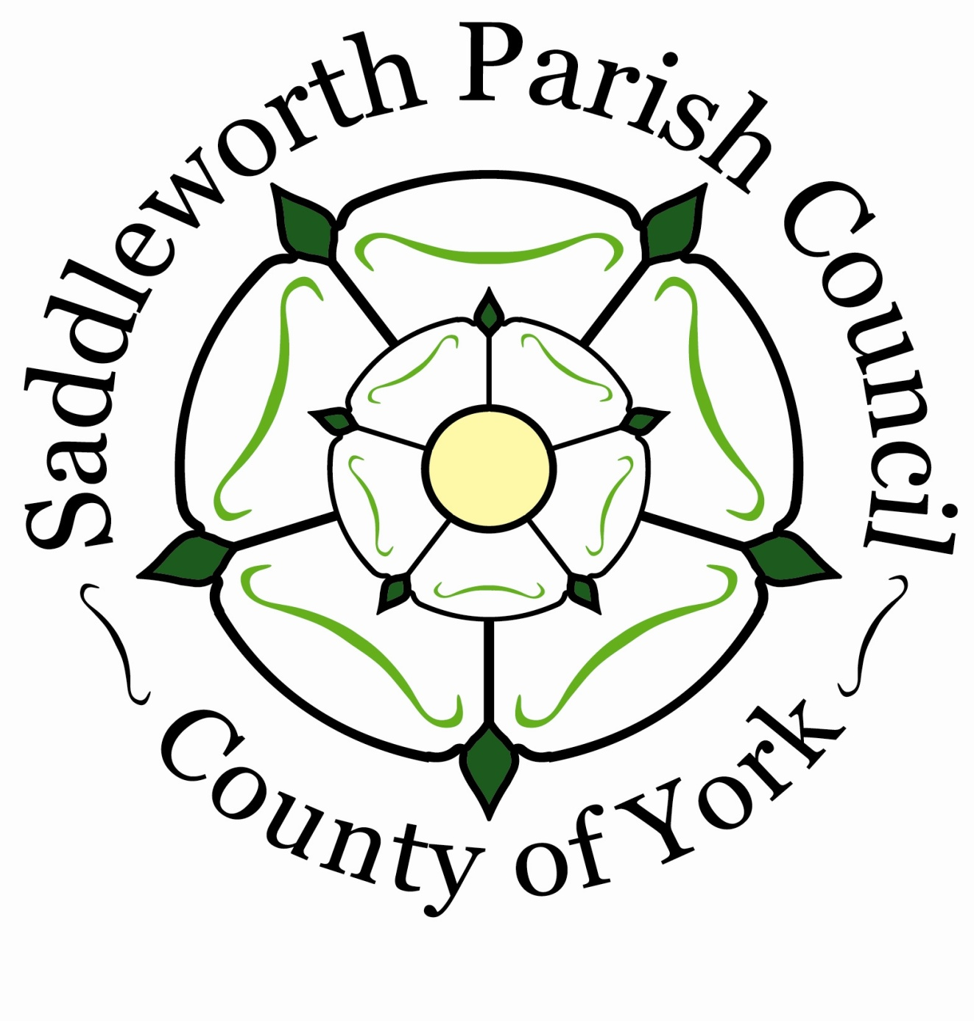
SADDLEWORTH

Parish Council

15th April 2026
To: All Members of the Saddleworth Parish Council
Dear Sir/Madam
You are hereby summoned to attend the Ordinary Council Meeting of the Parish Council to be held at the Civic Hall on Monday 27th April 2026 at 7.30pm for the purpose of conducting the under mentioned business.
Yours faithfully
K E Allott
Clerk to the Council
AGENDA
Welcome by the Chair
A Minute’s Silence to be held for Mr Phil Woolas

- To receive apologies for Absence
- To receive Declarations of Interest
- To Receive Public Questions
- Chair’s Urgent Business
- To receive a written application for the office of Parish Councillor and to co-opt a candidate to fill the existing vacancy
- Correspondence
- Network Rail Response to the Parish Council’s Statement of Case
- Response from North West Ambulance Service in relation to response times.
- United Utilities Response to the Council’s recent correspondence in reference to the January Meeting Motion on Moorland Management
Notice of Motion - Recognising and Protecting the Rights of Rivers in Saddleworth Parish
Proposed by: Cllr Alicia Marland; seconded by: Cllr Sam Al-Hamdani
This Council recognises that rivers are vital to the ecological health, cultural heritage, and future sustainability of Saddleworth. The Parish is home to many beautiful rivers and brooks in the UK, including the Rivers Tame, Chew, Medlock and Woodbrook, providing habitats for unique and endangered species, supporting livelihoods, recreation, and the wellbeing of our residents.
Despite this, Saddleworth’s rivers and brooks face growing pressures from pollution, climate change, land management, and development. Existing environmental protections are not preventing ongoing ecological decline. The United Nations has urged a fundamental shift in how humanity relates to nature, recognising our dependence on healthy ecosystems.
To address these growing threats and to uphold our responsibilities to future generations, this Council resolves to formally recognise the Rights of Rivers, drawing inspiration from the Universal Declaration of the Rights of Rivers. These include, but are not limited to:
• The right to flow – unimpeded, seasonal, and natural.
• The right to perform essential functions within the ecosystem.
• The right to be free from pollution and contamination.
• The right to feed and be fed by sustainable aquifers and other freshwater sources.
• The right to native biodiversity and restoration of ecological integrity.
• The right to regeneration and restoration from environmental harm.
This Council therefore resolves to:
- Acknowledge the intrinsic rights of rivers within the jurisdiction of Saddleworth Parish Council.
- Work with community groups, river trusts and environmental experts to identify and support the legal and practical recognition of these rights.
- Embed river rights principles into Council policies, particularly those concerning planning, development, land use, water management, and biodiversity.
- Advocate to national and regional bodies, including the Environment Agency, to adopt river rights frameworks and enhance protections for our freshwater ecosystems.
- Support local initiatives and citizen monitoring efforts that protect and restore river health, such as citizen science water testing, riparian buffer planting, and sustainable agriculture partnerships.
- Request that the Environment Agency publishes an annual "State of the Rivers" report to track progress.

- To approve and confirm as a correct record the Draft Minutes of the Council Meeting held on 23rd February 2026
- To note the minutes of the Strategic Planning Committee Meeting held on 26th February 2026
- To note the minutes of the Planning Committee Meeting held on 2nd March 2026
- To note the minutes of the TTE Committee Meeting held on 16th March 2026
- To note the minutes of the Joint Assets & Finance Committee Meeting held on 19th
March 2026
- To note the minutes of the Planning Committee Meeting held on 7th April 2026
- To note the minutes of the Finance Committee Meeting held on 13th April 2026 (to follow)
- Action Together Funding Application Update
- Accounts for Payment:
February 2026 Income £ 13,423.80 Expenditure £ 23,060
March 2026 Income £ 15,179.25 Expenditure £ 29,942.65
Payments List, see appendix 1

- Annual Meeting - Microphones for discussion
- Cllr Beeley Discussion around 2026-2027

Date of the next meetings:
Monday 11th May 2026 at 7.30pm - Association of Councillors Meeting
Monday 18th May 2026 at 6.15pm - Annual Parish Meeting
Monday 18th May 2026 at 7.30pm - Annual Meeting

Appendix 1

